EXPERIMENT 1
DDL COMMANDS-Creat,Alter,Drop
S Sayed Sahil
192525397
AIML
CSA0501

1.
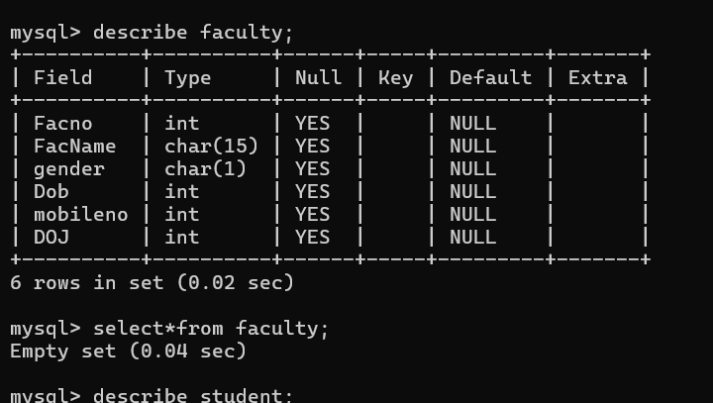
2.
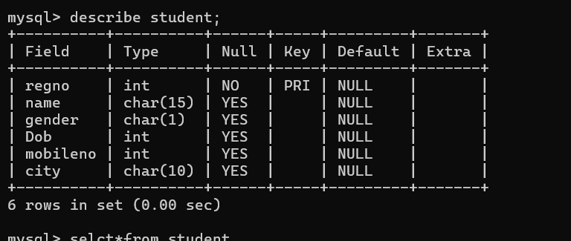
3.
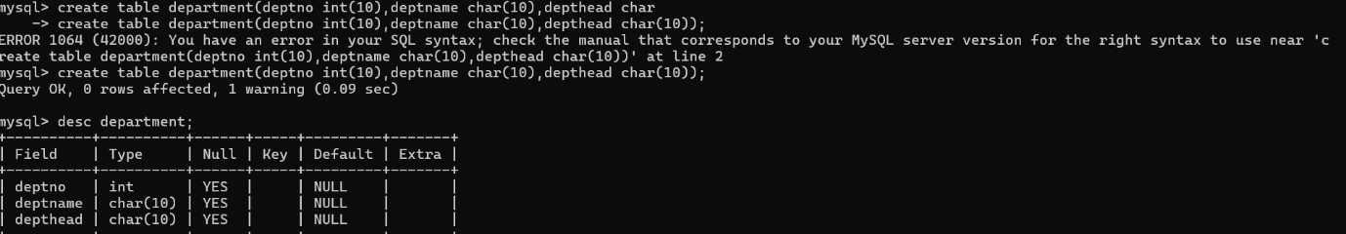
4.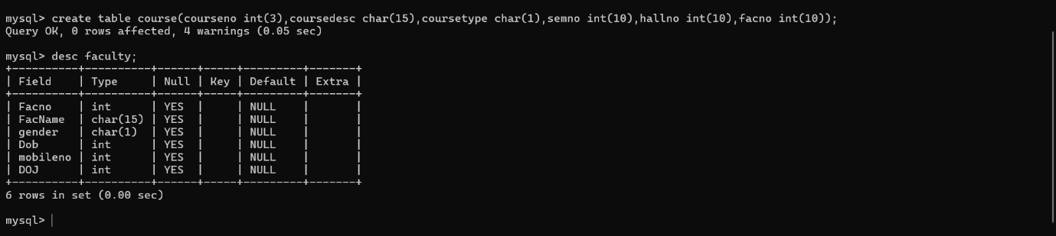
5.